Asilo, Mark Rainier T.

2 ECE – A

Experiment 9: Data Wrangling Using Pandas

Problem 1

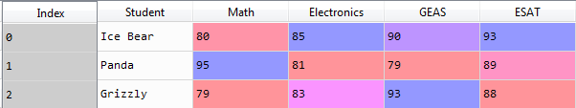

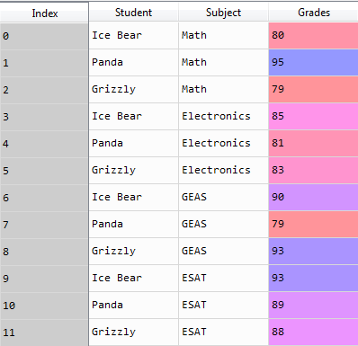

Problem 2

